Task Day 8 : Write some of the queries using ANY, ALL and SOME statements in MySQL

1. Usage of **ANY** statement:

Any returns a true value when any of the sub-query values meets the condition on the main query.

Retrieve the name (first name, last name) and salary from the table employees if the salary for the employee is equal to the maximum salary of the job with the title ' Programmer' using **ANY** statement

select first_name, last_name, salary from

employees where salary = ANY (select Max_salary from jobs where Job_title = 'Programmer');

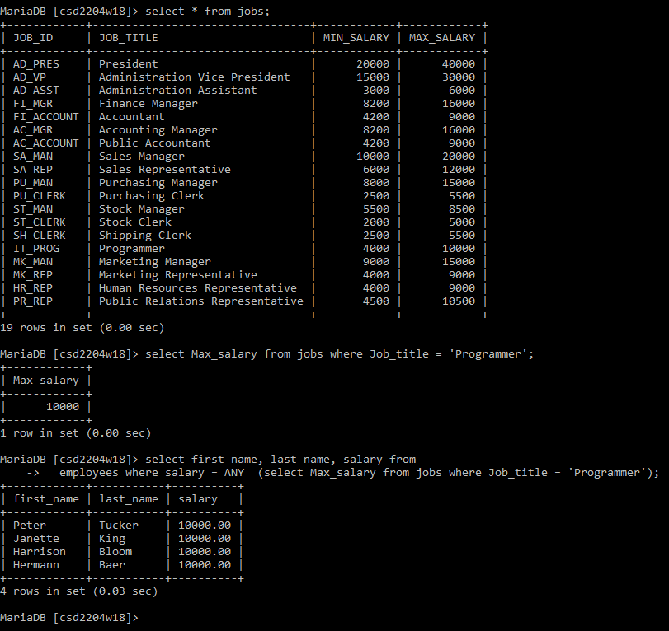

1. Usage of **ALL** statement:

ALL returns a true value when all of the sub-query values meets the condition on the main query.

Retrieve the name (first name, last name) and salary from the table employees if the salary for the employee is equal to the maximum salary of the job with the title ' Programmer' or ‘Stock Clerk’ using **ALL** statement

select first_name, last_name, salary from

employees where salary = ALL ( select Max_salary from jobs where job_title = 'Programmer' or job_title ='Stock Clerk');

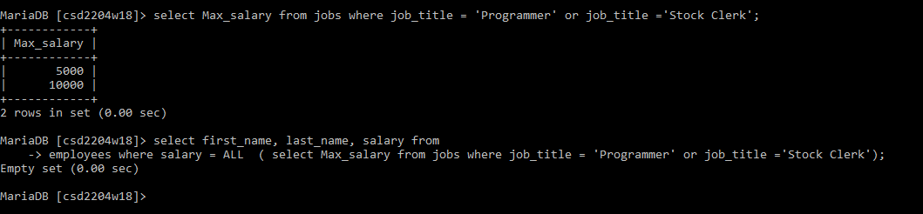

1. Usage of **SOME** statement

‘SOME’ statement is an alias for **‘ANY’** statement.

Retrieve the name (first name, last name) and salary from the table employees if the salary for the employee is equal to the maximum salary of the job with the title ' Programmer' using **ANY** statement

select first_name, last_name, salary from

employees where salary = SOME (select Max_salary from jobs where Job_title = 'Programmer');

